Assignment 1: Packet Tracer - Build a Switch and Router Network Report by Ezekiel Waweru CNS06-24049

Introduction
This was a lab assignment to build a switch and router network and get familiar with the workings of the network topology.

Part 1: Set Up Topology and Initialize Devices

Step 1: Cable the network as shown in the topology.

a. Attach the devices shown in the topology diagram, and cable, as necessary.
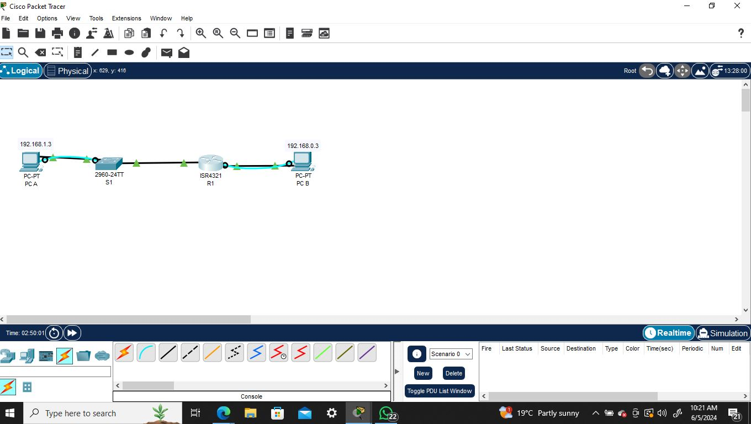
b. Power on all the devices in the topology.
Step 1: Assign static IP information to the PC interfaces.

a. Configure the IP address, subnet mask, and default gateway settings on PC-A.
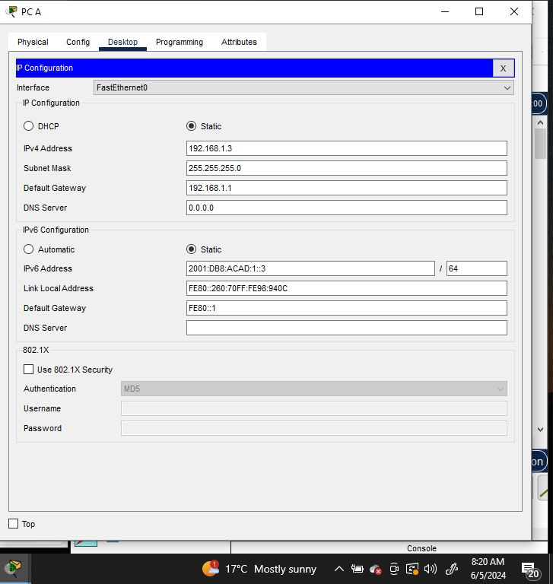
b. Configure the IP address, subnet mask, and default gateway settings on PC-B.
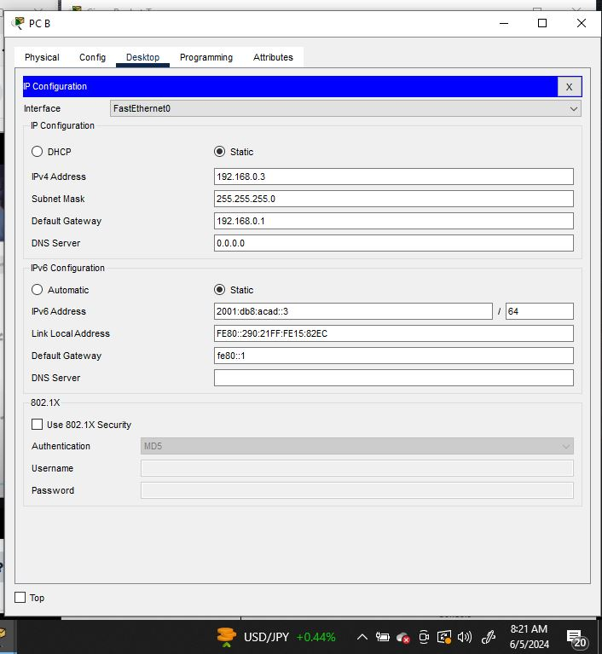
c. Ping PC-B from a command prompt window on PC-A.
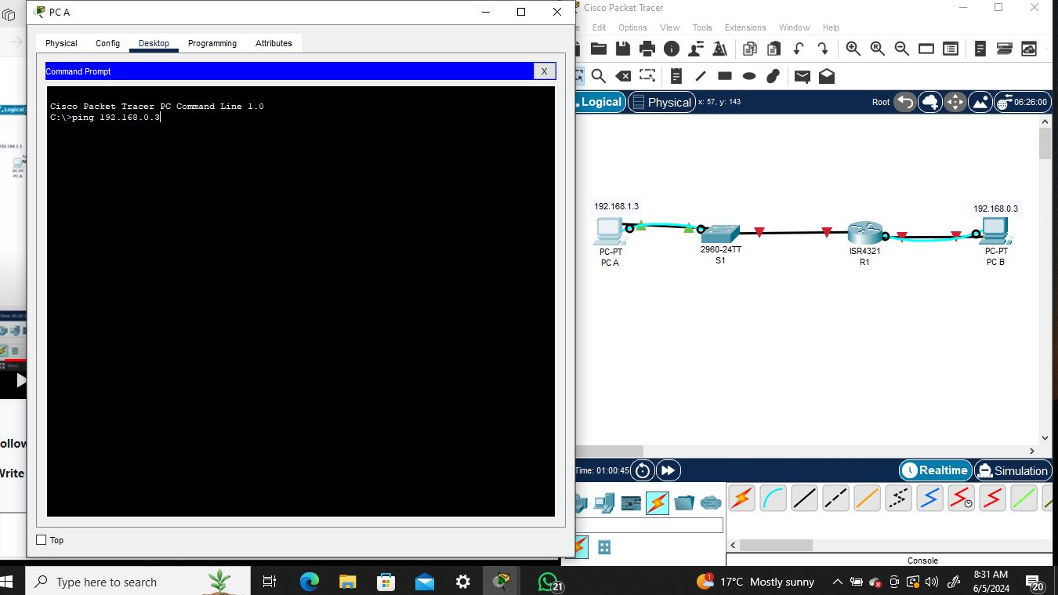
Question:

Why were the pings not successful?
The pings were unsuccessful. I had switched off the both firewalls for PCA and PCB. PC A failed to ping PC B because the router was not configured.
PC A firewall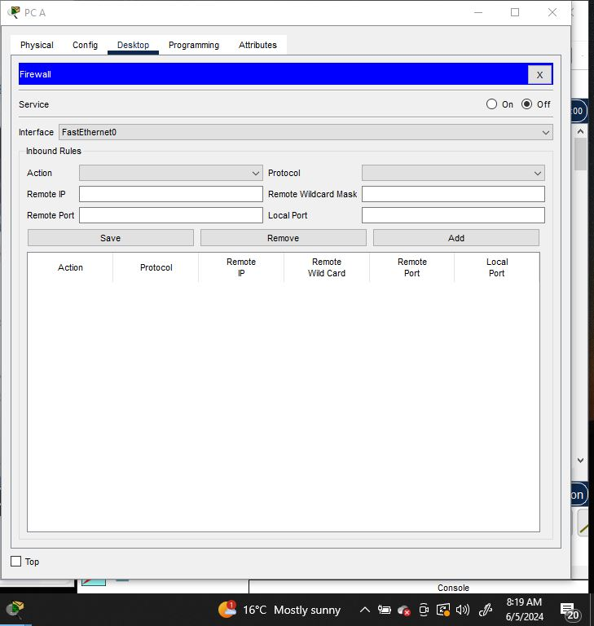
PC B firewall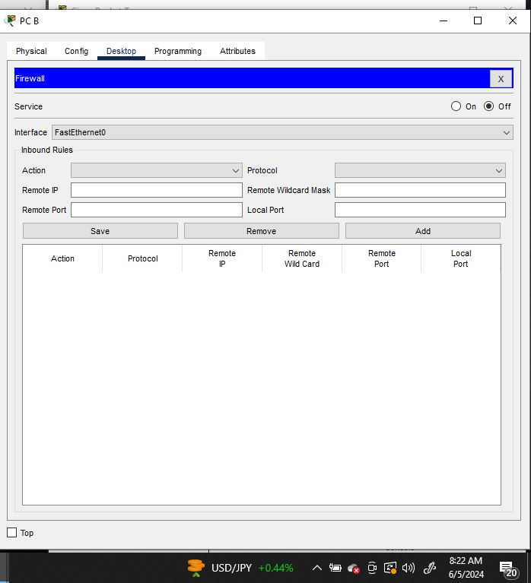
Step 2: Configure the router.
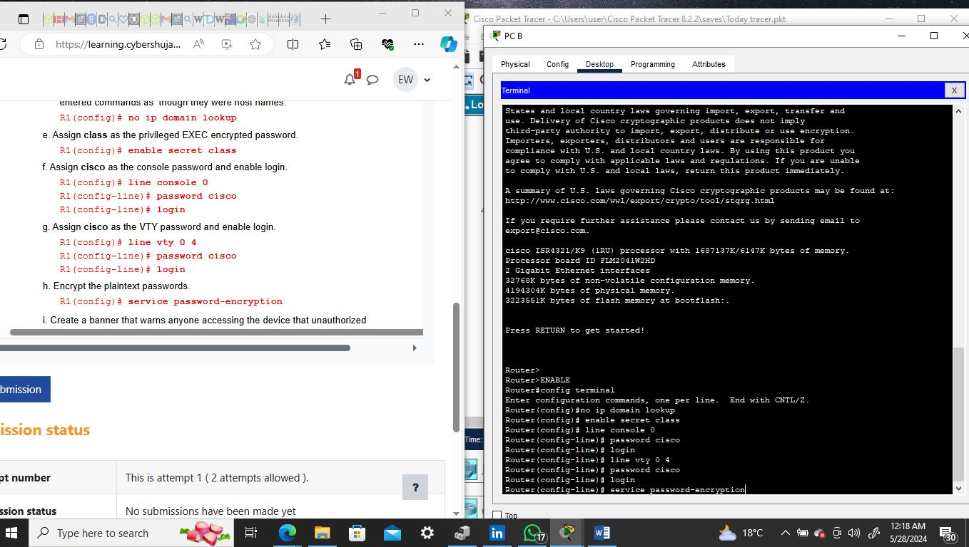
In configuring the router, I run several commands. The first one was enable which allowed me to use the console in privileged EXEC mode. From there, I entered the configuration terminal and assigned a device name to the router. The next step was to disable DNS lookup to prevent the router from attempting to translate incorrectly entered commands, as though they were host names.
I then assigned class as the privileged EXEC encrypted password. Next step was to assign cisco as the console password and enable login. After that, I assigned cisco as the VTY password and enabled login. As security was a top priority, I encrypted the plaintext passwords. In addition, I created a banner that warns anyone accessing the device that unauthorized access is prohibited. After, I configured and activated both interfaces on the router. I then configured an interface description for each interface indicating which device it is connected to. Enabling IPv6 routing was next, by entering the ipv6 unicast-routing command. All this was finalized by saving the running configuration to the startup configuration file.
window

o. Ping PC-B from a command prompt window on PC-A. Were the pings successful? Explain.
The Ping was successful as the router is now configured and a connection has been established between the two subnets. There is still one packet that got lost
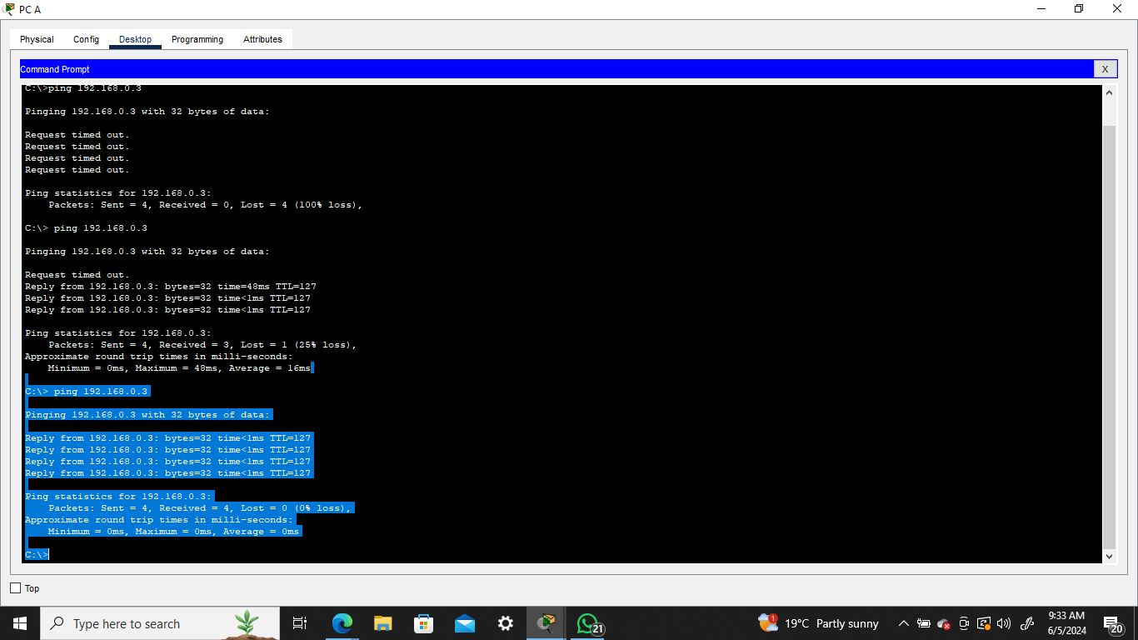
Step 3: Configure the switch.
I consoled into the switch and enabled privileged EXEC mode. After entering configuration mode, I assigned a device name to the switch, which was hostname. I disabled DNS lookup to prevent the router from attempting to translate incorrectly entered commands as though they were host names. Next step was to configure and activate the VLAN interface on the switch S1. The final step was to configure the default gateway for the switch S1 and to save the running configuration to the startup file.
Step 4: Verify connectivity end-to-end connectivity.

- From PC-A, ping PC-B.
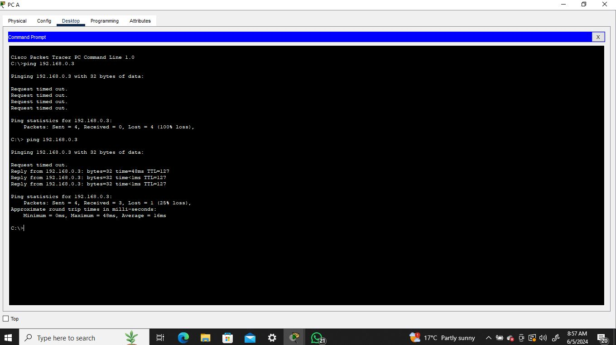

- From S1, ping PC-B.
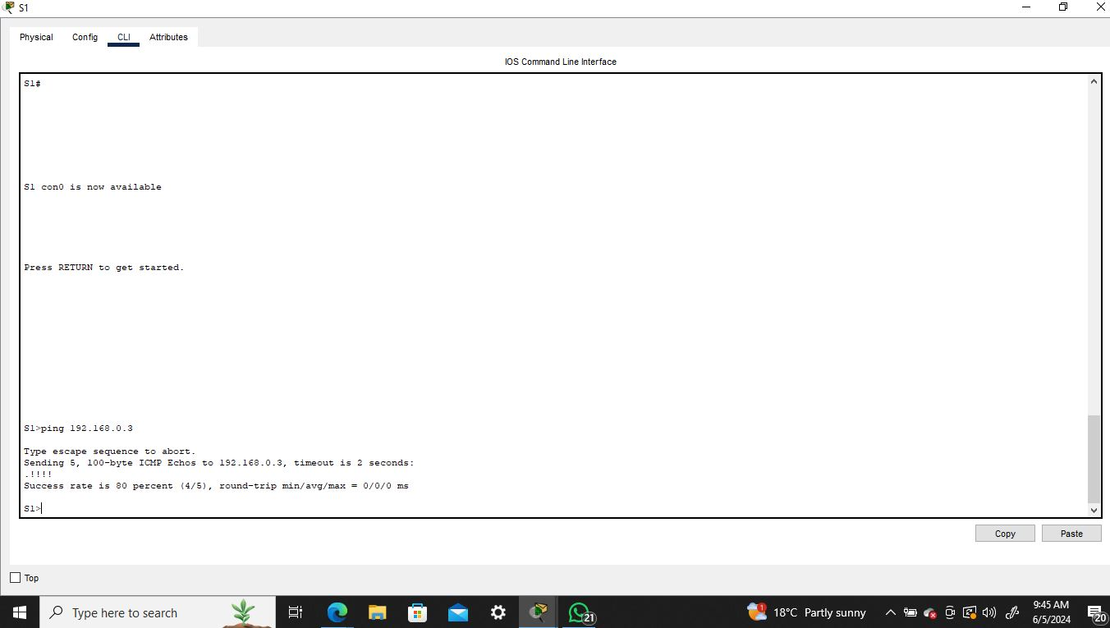

Part 3: Display Device Information
Step 1: Display the routing table on the router.
- Use the show ip route command on the router R1 to answer the following questions.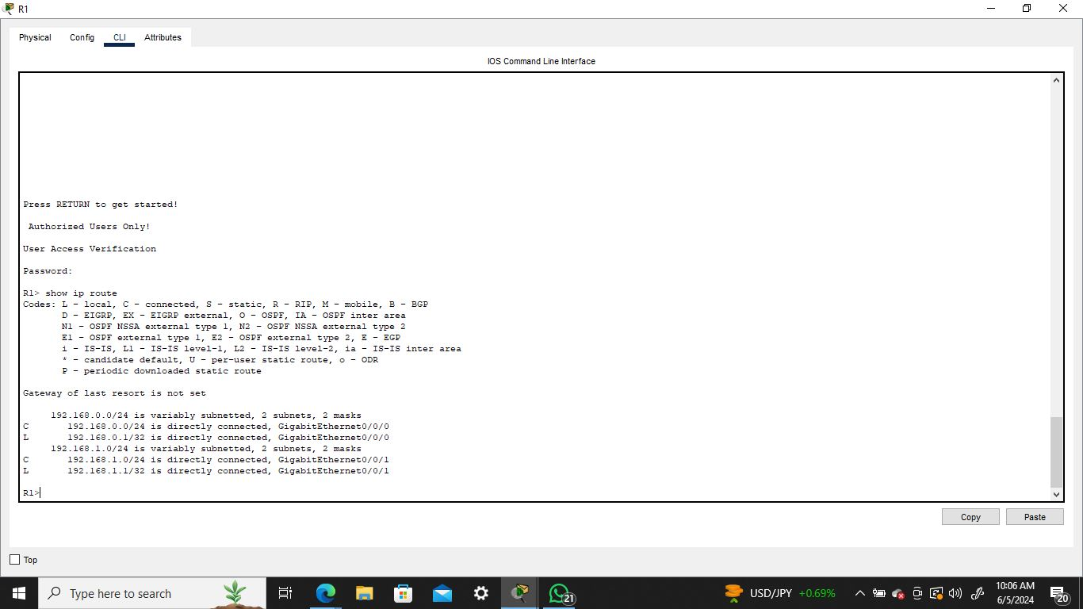
- What code is used in the routing table to indicate a directly connected network?
C
- How many route entries are coded with a C code in the routing table? 2
- What interface types are associated to the C coded routes? G0/0/0 and G0/0/1
- Use the show ipv6 route command on router R1 to display the IPv6 routes.
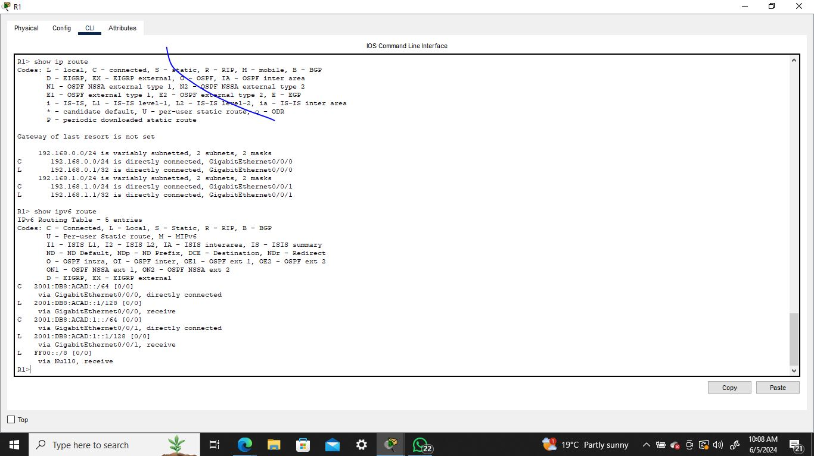
Step 2: Display interface information on the router R1.

- Use the show ip interface g0/0/1 to answer the following questions.
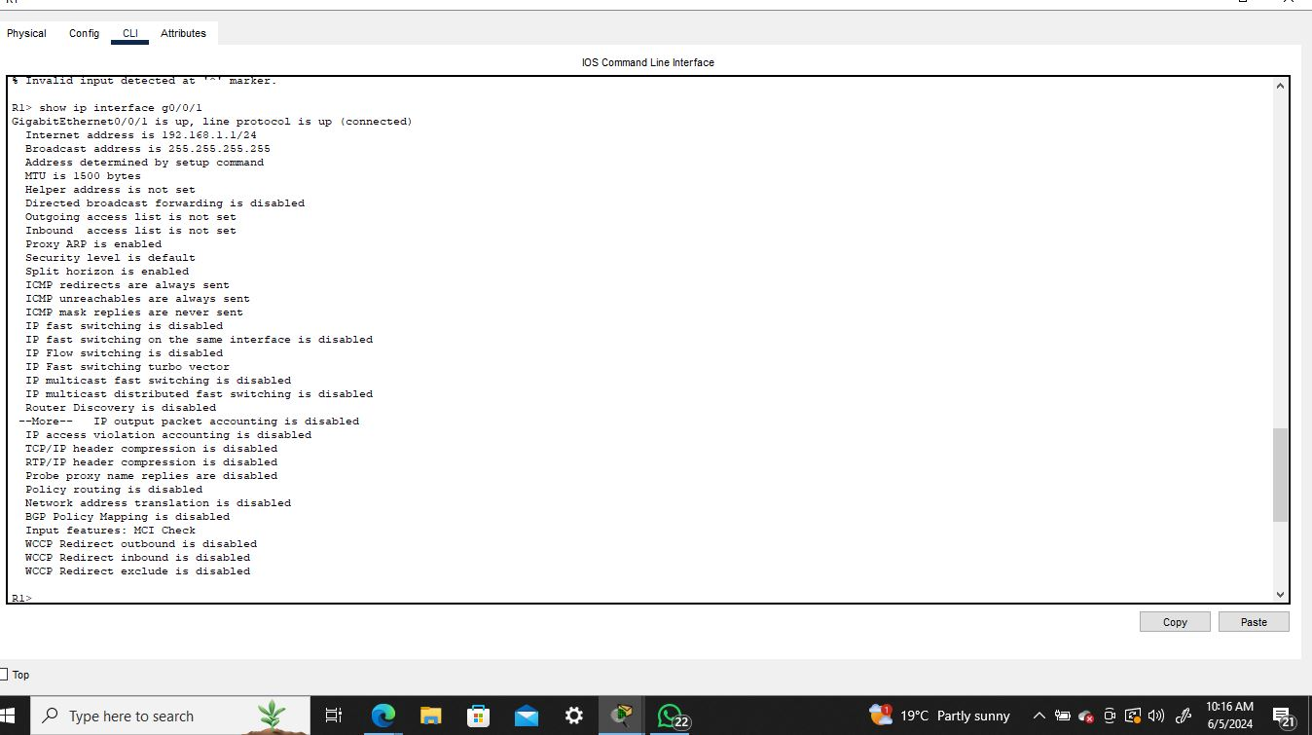

Conclusion
This lab was educative and it helped get familiar with packet tracer and how to configure routers, a switch and also how communication works between networking devices in a similar subnet.

